From Desert to City: Project Write-Up
Lindsay Polaski
Geography, University of Colorado Colorado Springs
GES 3060: Environmental Remote Sensing
May 11, 2025

1.0 Introduction
If you have ever been to the city of Las Vegas during the summertime, you know it can get extremely hot. How has the city of Las Vegas’ land change cover from 1990 to 2020 contributed to the Urban Heat Island effect.? Landsat (5, 7, and 8) and Terrset2020 are able to identify the shifts in Las Vegas’ urban sprawl and the vegetation loss (Normalized Difference Vegetation Index-NDVI) and surface temperatures that come along with it.
Over the past 30 years, Las Vegas has seen a dramatic increase in urban sprawl and development. Urban sprawl is when new growth occurs in scattered patches throughout a city over time. Before remote sensing data became more available, urban sprawl was difficult to measure. The measurement of growth for urban sprawl relied on ground surveys and census data. As of the late 20th century, remote sensing data has made tracking land use/ change cover much more cheaper, accurate, and efficient (Stuht, 2022). Since 1990, the city’s population and tourism has grown rapidly, leading to the expansion of built-up land, commercial areas, and infrastructure. The urbanization of the city leads to the expense of land covers like desert and vegetation, completely transforming the thermal and ecological characteristics of the city and the region around it.
An environmental consequence of the growth of the city is the Urban Heat Island effect. The Urban Heat Island effect occurs when urban areas produce more heat than the areas surrounding it. This happens when moisture-retaining surfaces (organic matter like soil) are replaced with new surfaces like asphalt and concrete. The asphalt and concrete then absorb and re-emit heat much easier than natural organic material. As vegetation decreases in arid environments like Las Vegas, surface temperatures will intensify.
Remote sensing can be used to monitor Las Vegas for studying urban development and the Urban Heat Island effect. Landsat imagery can provide accurate, long-term data over the last 30 years. This allows the process to observe multispectral data to calculate vegetation indices (this project uses NDVI) and surface temperature with thermal bands. The repeated classifications, NDVI, and thermal observations will make it ideal to analyze land cover change and the environmental effects on the city of Las Vegas.

2.0 Literature review
Similar studies have increased the leverage remote sensing has to offer when analyzing patterns of urban development. This field of research has created a community of researchers who commonly use satellite imagery, such as Landsat, to observe historical changes in land cover. Recent achievements regarding remote sensing have enhanced the understanding of dynamic land cover change and the Urban Heat Island effect in urban regions like Las Vegas. A recurring theme in many different research articles is the use of Landsat imagery (predominantly TM, EMT+, and OLI/TIRS) to monitor long term changes in land cover in urbanized regions and the thermal reaction. Stephen (2018) and Gandhi (2015) both present the use of how NDVI land cover classifications methods can be used to look at urban expansion and vegetation loss over time. When looking specifically at Las Vegas, Stephen (2018) applies NDVI to understand the relationship between impervious surfaces (materials like asphalt and concrete) and surface temperature. This ultimately showed that built-up areas will alway correspond with a higher land surface temperature (LST). This study shows the importance of vegetation as a cooling factor in urban environments and ensures that remote sensing indices (like NDVI) can be used to monitor dynamics in vegetation over a period of time.
However, other forms of literature suggest that there are some limitations in the methodology in NDVI due to its seasonal sensitivity and non related relationship with temperature. Marcoif and Statscu (2017) bring up the fact that the Normalised Difference Built-up Index (NDBI) is much more stable and is not easily manipulated by seasonal variations. This methodology can be used when measuring the Urban Heat Island effect intensity in a study region. In Lasi, Romania, Marcoif and Satscu used NDBI as a reliable tool for urban heat assessment. The results offered the same insight as Stephen (2018), showing that the application of indices when monitoring land change cover in an urbanized city offer context on surface temperature increase and the intensification of the Urban Heat Island effect. This additional insight of the use of NDBI offers stronger research for urbanized regions that suffer from land change cover beyond vegetation alone. On top of NDVI and NDBI, researchers have increased the usage of supervised and supervised classifications to enhance the research of the Urban Heat Island effect.
While Shannon’s Entropy is not used in this specific Las Vegas study, Stuht uses this method in in Las Vegas study of sprawl from 2000 to 2020. This new method introduces another important advancement in monitoring urbanized regions with remote sensing by looking at spatial disorder and urban expansion. This complements the findings Sun (2022) found, who was using Landsat to study the relationship between land surface temperature and land cover and how it can vary spatially in different environments. Sun used geographically weighted regression to explore how the Urban Heat Island effect in Phoenix, AZ affects the suburbs compared to the inner city. Similarly, a MODIS study showed the effects in Las Vegas (Xian, 2006) found that lower elevations will have higher surface temperatures than those with a higher elevation. This reveals that terrain has a large effect on urban heat distribution. When collectively combining all these researchers' ideas with use of methodology, we can see how studying remote sensing can enable an understanding of the Urban Heat Island effect, vegetation loss, land use, and urban topography. These all could be used when keeping in mind future urban planning.

3.0 Data
This project utilized Landsat imagery provided for free on the USGS Glovis government website. Landsat satellite imagery is focused on the study region, Las Vegas Metropolitan area and city outskirts. This is used to evaluate land cover and thermal changes in the city over time. The 1990 image was taken by Landsat 5 Thermal Mapper (TM) on August 20, 1990. The 2001 image was taken by Landsat 7 Enhanced Thermal Mapper (ETM+) on June 7, 2001. Lastly, the 2020 image was taken on Landsat 8 Operational Land Imager (OLI) on August 17, 2020. The spatial resolution for the bands in the multispectral bands in all three satellites sensors is 30 meters. The spatial resolution for the thermal bands in all three satellites are resampled to 30 meters as well. The imagery was captured from summertime months to reflect peak vegetation stress as well as maximum temperatures in the city. This is perfect for when looking at the Urban Heat Island effect and the conditions that are associated with it.
The selection of data from June-August in 1990, 2001, and 2020 ensure temporal consistency over decades and minimize the variation between seasons. All images were cloud free (hense 2001, rather than 2000), which is critical when looking at land cover classifications and NDVI. The use of Landsat imagery additionally allows for better direct comparisons for surface temperature and surface conditions over time. Finally, the freely available access to Landsat data makes it very easy to study urban analysis, allowing the observation of trends in urban expansion and surface conditions over a period of time.
In addition to Landsat imagery, this report incorporates climate data collected from the Landsat imagery to support interpretation of the results from the Urban Heat Island effect. More specifically, the average temperature from the central region of the city was collected from all three images and contextualized into a graph. The thermal temperatures were summarized into a graph and compared alongside NDVI and land cover classifications in order to understand correlations between vegetation loss, temperature rise, and land cover change. This graph will be a supporting dataset by enhancing the spatial analysis of the surface temperature in the city over time. Additionally, other outside sources include Google Earth, base maps, and true color composites in order to get a visual interpretation to assign clusters to classes when creating classifications. For true color composites with Terrset2020, converting TIFFS files to raster format, stacking relevant spectral bands, and subsetting the image to Las Vegas Metropolitan region allowed for more accurate classifications. Each scene was analyzed through unsupervised classifications and NDVI to track land cover and vegetation change in the city.

4.0 Methods & Results
In order to classify the change in land cover in Las Vegas in 1990, 2001, and 2020, the unsupervised classification tool in Terrset 2020 can be applied. There are 5 informational classes that clusters can form from: 1. Water, 2. Vegetation, 3. Desert/ Open Space, 4. Commercial, and 5. Residential. For the 1990 imagery, 14 spectral clusters were created and then recorded into the 5 informational classes. The 2001 image has 13 spectral clusters, and the 2020 image has 16 spectral clusters. Band combinations for each sensor were used and later converted from a GeoTIFF image to a raster image. As a result from the classifications map, urban development maps were created to interpret and assign spectral clusters to a more meaningful land cover category (informational classes).
Vegetation change and surface conditions contributing to the Urban Heat Island effect can be monitored and observed with NDVI on all three images using the following equation:
(NIR-Red)
NDVI= —----------------
(NIR+Red)
(D’Allestro and Parente, 2015).
Using Band 4 and 3 for Landsat 5 and 7, and bands 5 and 4 for Landsat 8, NDVI values were able to assess the vegetation health and coverage (higher values indicate healthier, denser vegetation). In addition to NDVI, thermal bands were reviewed to accurately assess the land surface temperature difference. Landsat 5 and 7 used band 6 while Landsat 8 used band 10. This offers further insight into the Urban Heat Island effect when considered alongside vegetation.
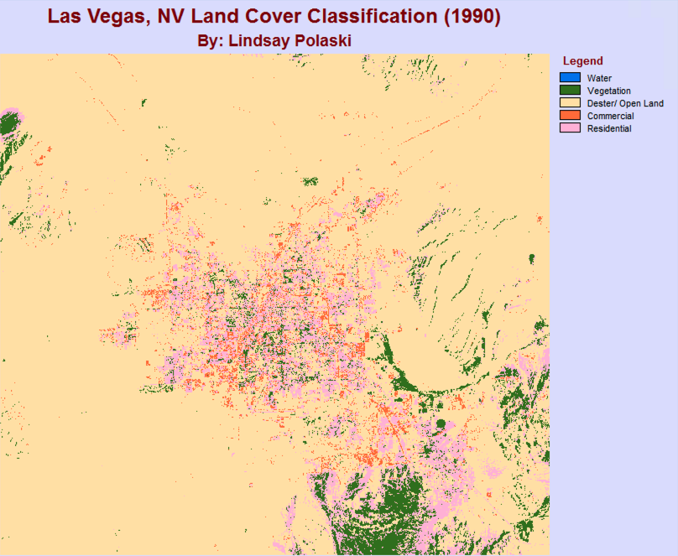
Figure 1a. Las Vegas, NV Land Cover Classification (1990) (Polaski, 2025).
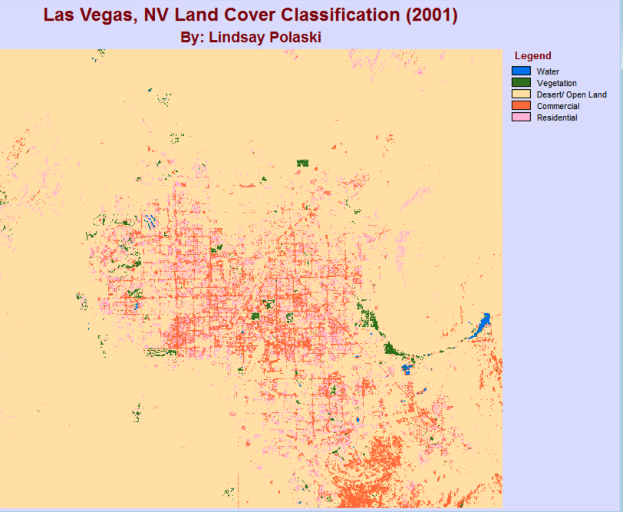
Figure 1b. Las Vegas, NV Land Cover Classification (2001) (Polaski, 2025).
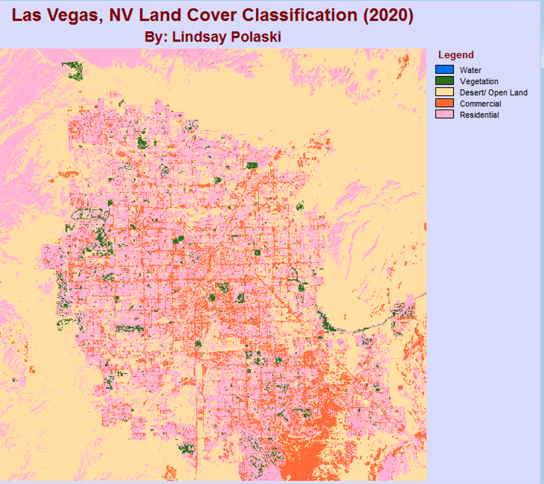
Figure 1c. Las Vegas, NV Land Cover Classification (2020) (Polaski, 2025).
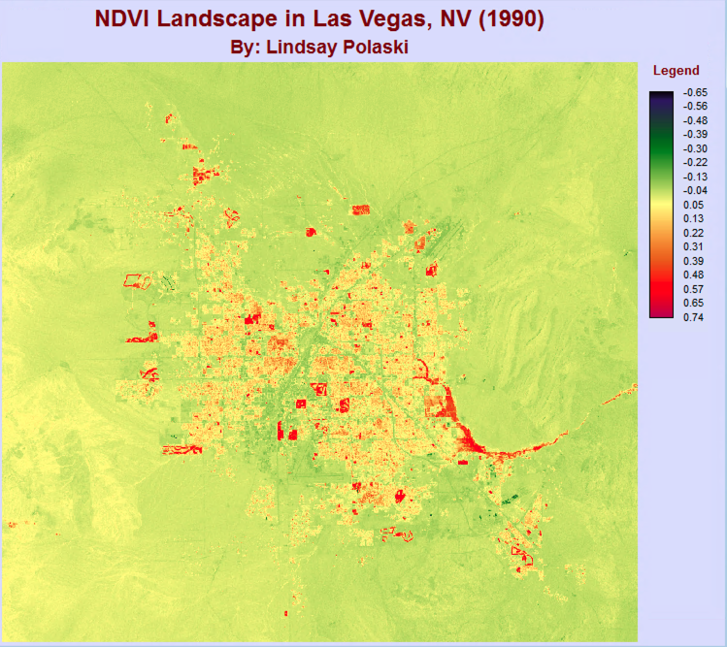
Figure 2a. NDVI Landscape in Las Vegas, NV (1990). (Polaski, 2025).
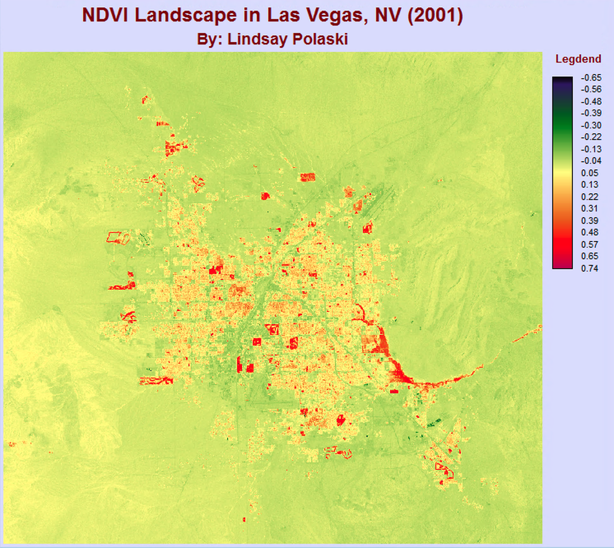
Figure 2b. NDVI Landscape in Las Vegas, NV (2001). (Polaski, 2025).
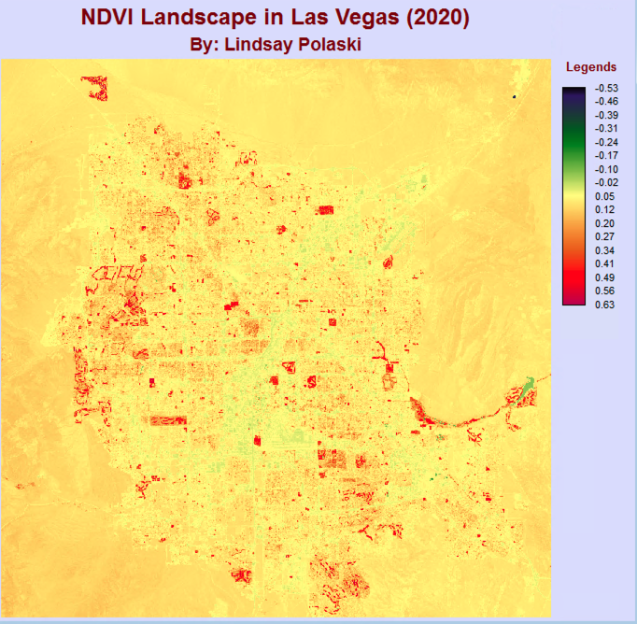
Figure 2c. NDVI Landscape in Las Vegas, NV (2020). (Polaski, 2025).
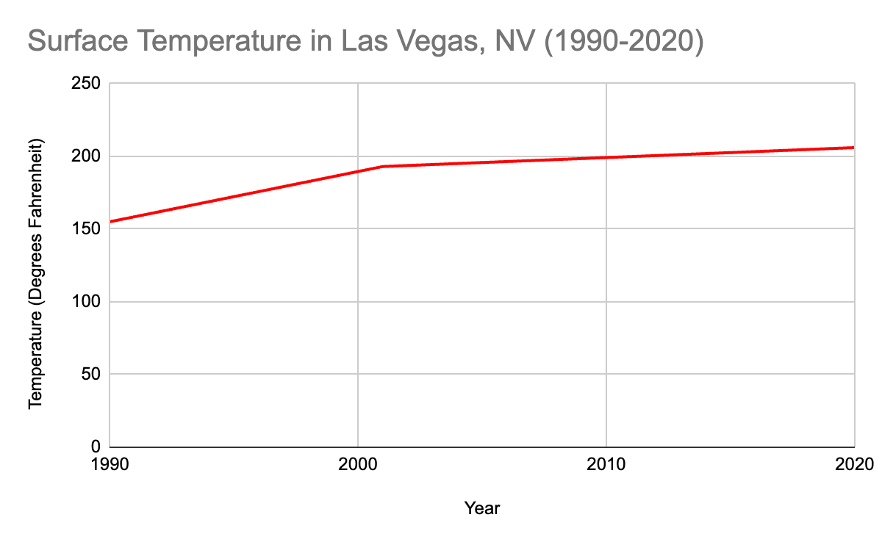
Figure 4. Surface Temperature in Las Vegas, NV (1990-2020) (Polaski, 2025).

The classification results show a significant expansion of residential and commercial areas between 1990 (Figure 1a), 2001 (Figure 1b), and 2020 (Figure 1c) with a corresponding reduction in vegetation and desert and open space land cover. In 1990, the urban footprint of the city was more concentrated in the central region of the city, with large expansions of desert land and sparse vegetation. Thirty years later and the city has sprawled outward on all sides. Heavy urban development can be seen in the north and southeast direction, replacing desert cover and vegetation. NDVI maps (Figure 2a, 2b, and 2c) showed a slight decline from 1990-2001, but had an unexpected increase by 2020. From 1990 to 2001, NDVI values decreased from 0.2 to 0.18, showing a decrease in vegetation. However, between 2001 and 2020, the average NDVI values increased to approximately 0.22. The 1990 and 2001 images were captured by Landsat 5 and 7, while the 2020 image is captured on Landsat 8. Due to Landsat 8’s improved resolution and variations in red and near infrared spectral bands, Landsat 8 can possibly create higher NDVI values than captured by previous models before it (Xu and Guo, 2014). These discrepancies, along with atmospheric conditions (such as air pollution or humidity) could have an influence on NDVI in the 2020 image. This upward shift suggests that this trend may be partially caused by differences in sensor calibrations in Landsat 8 versus Landsat 5 and 7. Despite the overall increase in NDVI values observed from 2001 and 2020, images show an increase even within arid desert regions. This pattern does not reflect a genuine increase in vegetation overtime. This pattern does not align with previously established land use records and ground-based surveys. The reduction of vegetation aligns spatially with residential and commercial areas identified in the classifications map. The table expresses surface temperature over the three decades (Figure 4) discussing the average temperature in bands 6 (for Landsat 5 and 7) and band 10 (for Landsat 8). The average temperature from 1990 to 2001 increased by 31 degrees fahrenheit, then increased again from 2001 to 2020 by 13 degrees fahrenheit. The consistent rise in temperature aligns with the urban sprawl and vegetation loss monitored in the classifications and NDVI maps (Figures 1 and 2). Areas with the most significant urban expansion also showed the most temperature increase, with some surface temperatures getting as high as 206 degrees fahrenheit. This temperature rise is a direct result from the reduction of vegetation and increase of non-natural surfaces (such as concrete and asphalt). The temperature data further supports the hypothesis that urban sprawl and vegetation loss leads to the Urban Heat Island effect in Las Vegas, NV.
These findings show the correlation between urban expansion and vegetation loss in Las Vegas and how that has contributed to the Urban Heat Island effect. The unsupervised classifications were effective in showing a general concept of how the city has expanded dramatically and how the land cover has changed over time. NDVI had provided a general index of vegetation change within the city. The combination of the classifications over the 30 year time period showed that land transformation from natural/ semi-natural surfaces to an urban, built environment. As vegetation surfaces were replaced with urban materials, the decline in surface cooling spread, likely intensifying the surface temperature. The results from this report contribute to a better understanding of the environmental trade-off with increased urban development and sprawl in arid environments.
While the study effectively showed the relationship between urban expansion to vegetation loss and temperature increase, there were a few limitations in research and methodology. While the use of unsupervised classifications provided a general description of land cover change, it lacked accurate precision that would have likely been better achieved with supervised classifications. Supervised classifications allow for more accurate mapping of land coverage while unsupervised classifications do most of the work for you, and usually will categorise cells inaccurately. To add onto this point, I found it challenging to assign categories to classes due to the general clustering Terrset did. If I were to redo this project, I would create more temporal spacing between time frames of imagery. Spanning from 1990 then 2001 is an 11 year difference, then I created a dramatic jump from 2001 to 2020, a large 19 year difference. I would have done a year like 2010 or 2015 to create a more even spanning of imagery over a decade. Moreover, including temperature data from intermediate years (1995, 2005, 2010, 2015) would enable a more structured analysis of the relationship of land cover change and average surface temperature. With these approaches, I would have better captured the difference in land change dynamics of Las Vegas while strengthening the relationship between NDVI and surface temperature. Future changes of this project could be to add additional remote sensing imagery (like topographical insight, mentioned by Xian [2006]) to show the real world change rather than colors and numbers on a screen to increase the classification accuracy as well as provide a visual for the observer of the project and maps.

5.0 Bibliography
D’Allestro, P., & Parente, C. (2015). GIS application for NDVI calculation using Landsat 8 OLI images. ISSN. https://d1net/
Gandhi, Meera. (2015). NDVI: Vegetation Change Detection Using Remote Sensing and GIS – A Case Study of Vellore District. ScienceDirect. https://www.sciencedirect.com/science/article/pii/S1877050915019444
Macarof, Paul, & Satescu, Florian. (2017). Comparison of NDBI and NDVI as Indicators of Surface Urban Heat Island Effect in Landsat 8 Imagery: A Case Study of Lasi. De Gruyter. http://archive.sciendo.com/PESD/pesd.2017.11.issue-2/pesd-2017-0032/pesd-2017-0032.pdf
Stephen, Haroon. (2018). Trend Analysis of Las Vegas Land Cover and Temperature Using Remote Sensing. MDPI. https://www.mdpi.com/2073-445X/7/4/135
Stuht, M. Casey. (2022). Las Vegas Metropolitan Area Urban Sprawl Assessment Using Shannon's Entropy. University of Arizona. https://repository.arizona.edu/handle/10150/664154
Sun, Maoran. (2022). Understanding Building Energy Efficiency with Administrative and Emerging Urban Big Data by Deep Learning in Glasgow. ScienceDirect. https://www.sciencedirect.com/science/article/pii/S0378778822005023
Xian, George. (2006). An Analysis of Urban Thermal Characteristics and Associated Land Cover in Tampa Bay and Las Vegas using Landsat Satellite Data. ScienceDirect. https://www.sciencedirect.com/science/article/abs/pii/S0034425706001799
Xu, Dandan, & Guo, Xulin. (2014). Compare NDVI Extracted from Landsat 8 Imagery with That from Landsat 7 Imagery. SciencePG. https://www.researchgate.net/profile/Dandan-Xu-2/publication/270820608_Compare_NDVI_Extracted_from_Landsat_8_Imagery_with_that_from_Landsat_7_Imagery.pdf

